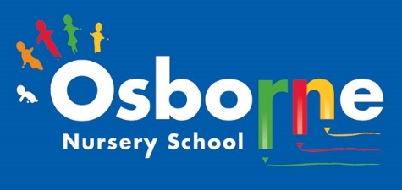
Osborne News
March 2026 
www. osbornenurseryschool.co.uk

Nursery News:
World Book Day will be celebrated at Nursery on Wednesday 4th March 2026. We are inviting everyone to dress up in their favourite costume or wear their favourite pyjamas to help celebrate our love of books. The staff will be sending you their favourite stories via Tapestry – we would love to hear about yours too. Look out for your free book token to spend on a book.
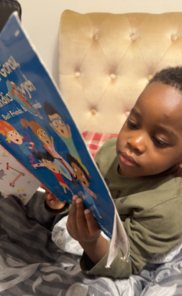

Dates for your diary:
Thursdays: Stay and Play (under 2s) every Thursday morning – 9:45 – 11:15am at OSBORNE NURSERY SCHOOL.
Wednesday 4th March –World Book Day – wear your pyjamas or dress up!
February – March – Ramadan
Eid Al Fitr – 19th/20th/21st March – To be confirmed
March 22nd 2026 – World Water Day
Monday April 13th onwards – home visits for new children and new 3 year olds to start nursery
Monday 30th March – 10th April - Easter holiday – nursery closed
Please remember to telephone us on 0121 675 1123 if your child is too ill to be at nursery. Please keep us updated with any changes of address or phone numbers. We miss you when you are not here!

Good luck with your reading challenge! Some children have started their challenges already!!

Attendance is very important at Nursery. We like to see you for all of your sessions each week. We like families to aim for attendance to be between 95 and 100%. Look out for the Cool Kittens stickers!
Congratulations to TADPOLES AM 91% and Squares AM 95% for the best attendance in Nursery in January 2025. FANTASTIC!! Well done to the parents and carers too.

Little Learners!
Little Learners have been exploring different ways to make music and making links to their core books and experiences. It’s a wonderful place to be!
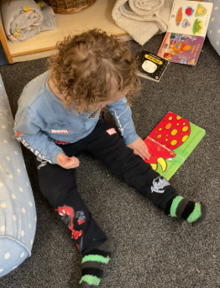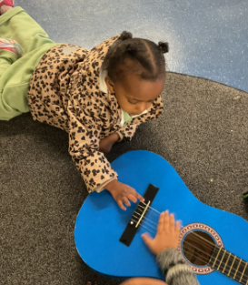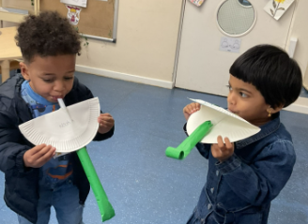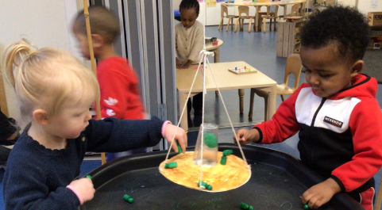

Rights Respecting Schools Award (RRSA)
This year we will be working towards reaccrediting out Rights Resecting Silver Award. You will have seen our posts about ‘ I have the right to a name’ and’ I have the right to play’
Ronnie Rabbit is helping the children understand their rights.


World Water Day- March 22nd, 2026
Its main purpose is to highlight the importance of freshwater and highlight those that do not have access to clean water around the world.

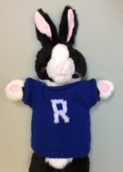

Internet safety:
Our message for March is to explore websites together that are safe for children. Use well known sites like CBeebies to find interactive activities for you to enjoy together. Talk about what you are doing and what you can see and hear. There are lots of stories and rhymes for young children to enjoy.

It is great to see the children bringing back their library books every Wednesday – we hope you are enjoying reading at home.
Recommended reading this month:

Explorers will be reading Handa’s Surprise and enjoying learning about the characters adventures and all the fruits and animals in the story. Little Learners will be reading Orange, Pear, Apple, Bear and will be focusing on the new words in their books and making links to their everyday lives.


Smiley Shen – It’s important to brush your teeth at least twice a day – the children have been learning about how to brush their teeth well. Ask your child about Smiley Shen!

Your Key Workers are busy writing your child’s Spring term reports. They will be sending these out to you via Tapestry with pictures of the year so far. They will let you know what they do well and enjoy learning about along with ways to get even better!

As the holy month of Ramadan begins, we would like to extend our warmest wishes to all families observing this special time. Ramadan is a period of reflection, compassion, and community, and we recognise the importance it holds for many of our pupils and their families.
Ramadan is expected to conclude with the celebration of Eid al-Fitr on March 20th 2026 (exact date dependent on the sighting of the moon). We would like to wish all those celebrating a joyful and blessed Eid. Eid Mubarak from all of us — we hope it brings happiness, peace, and time shared with loved ones.

